AI Assisted Coding (III Year) Assignment
Name: B. Rithwik
HT NO: 2303A52330
Batch: 35

Lab 11 – Data Structures with AI: Implementing Fundamental Structures
Week 6 – Monday

Lab Objectives
- Use AI to assist in designing and implementing fundamental data structures in Python
- Learn prompt-based design and optimization
- Improve understanding of Lists, Stacks, Queues, Linked Lists, Trees, Graphs, and Hash Tables
- Enhance code quality with comments and documentation

Task #1 – Stack Implementation
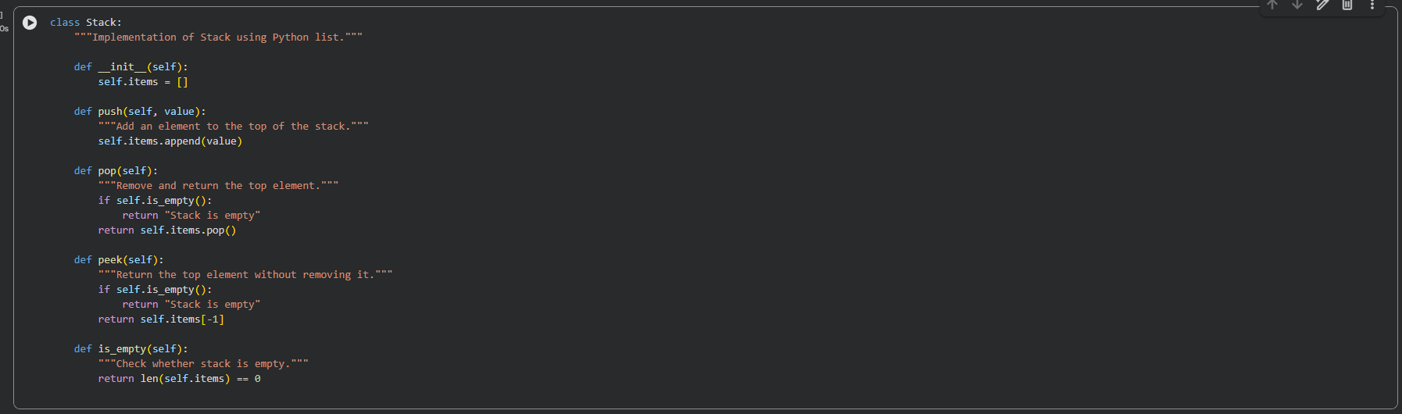

Task #2 – Queue Implementation
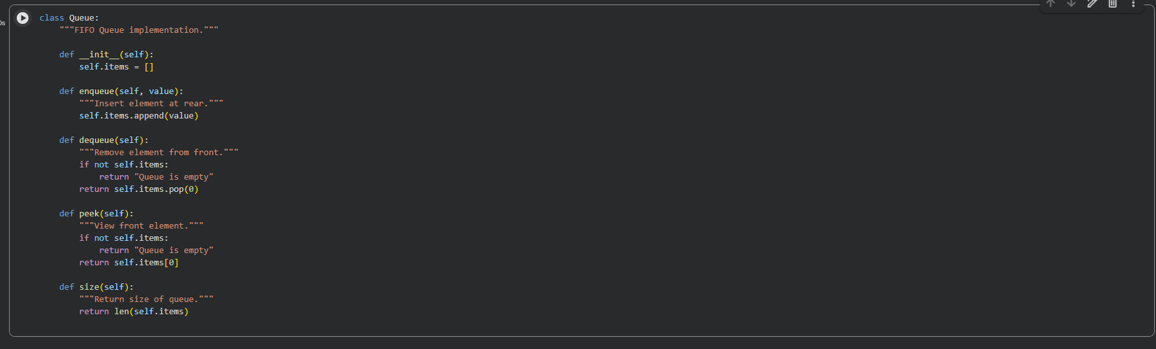

Task #3 – Singly Linked List
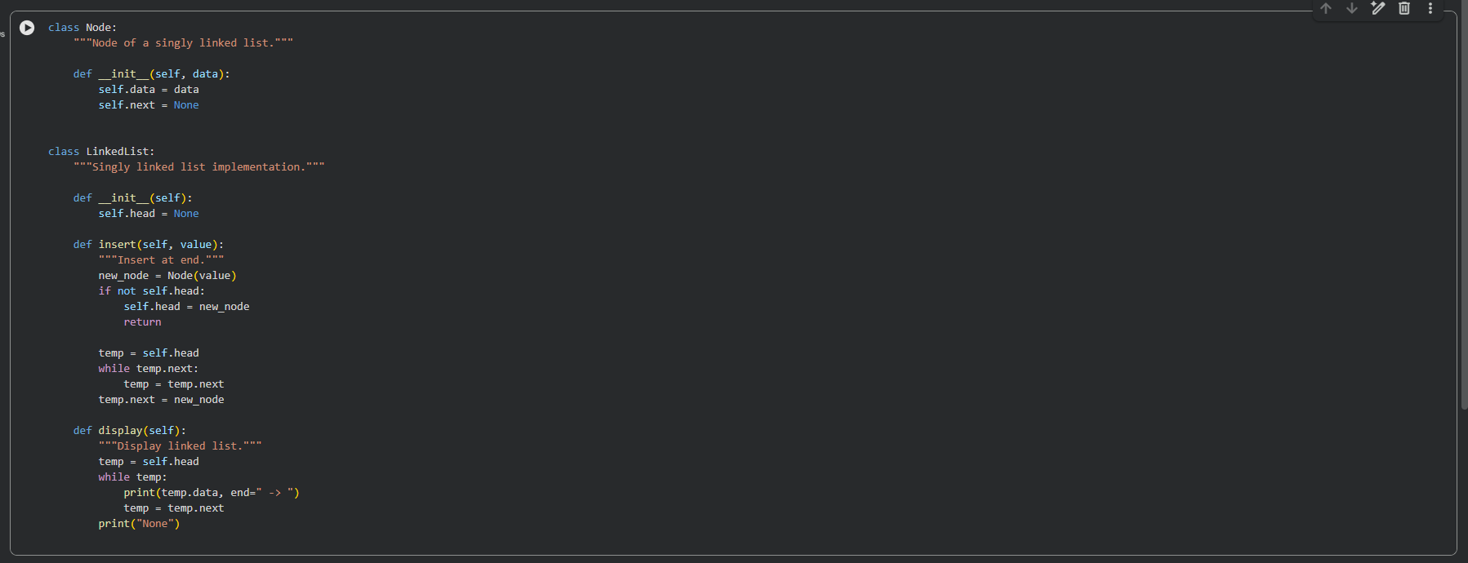
Task #4 – Binary Search Tree
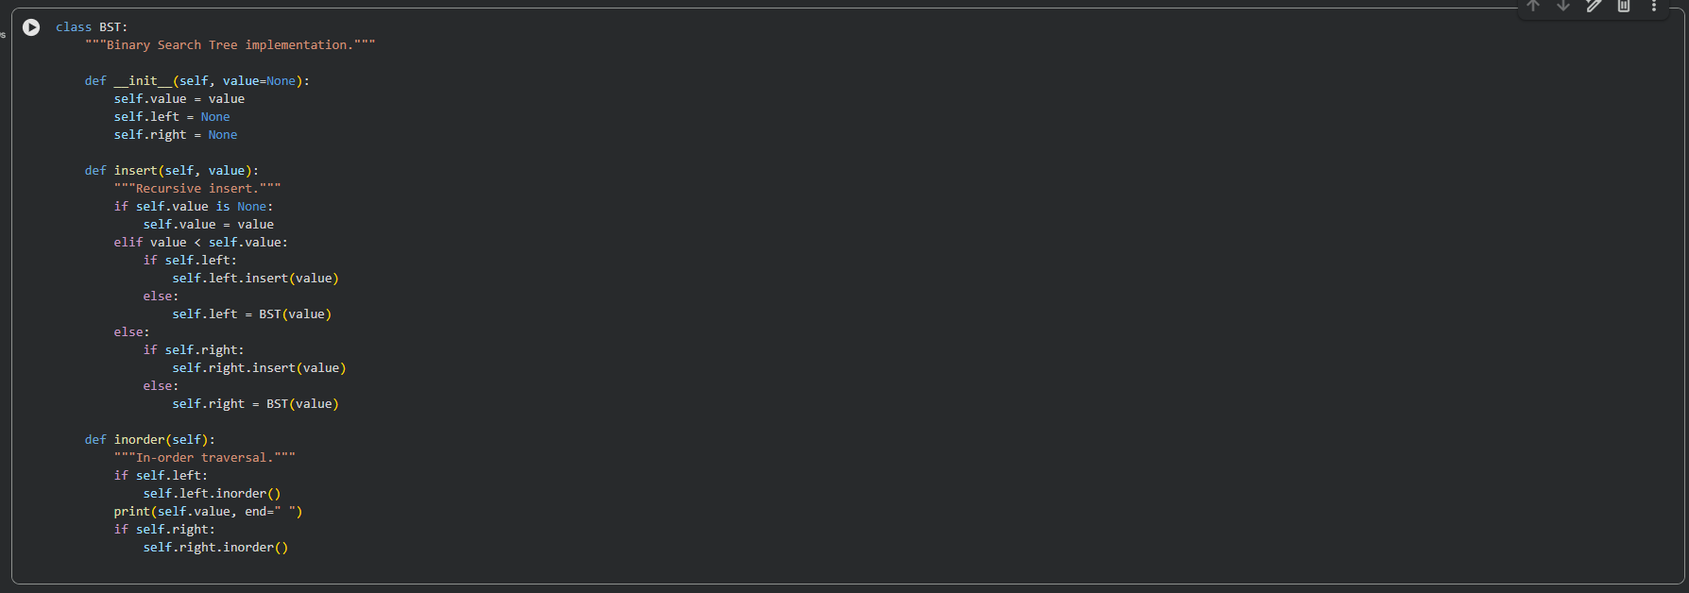

Task #5 – Hash Table with Chaining
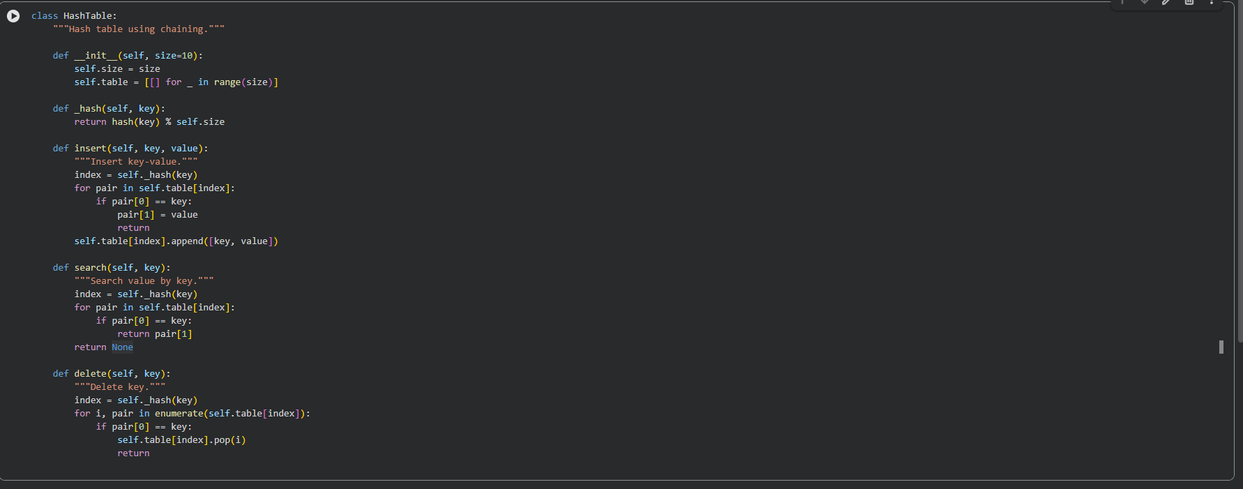

Task #6 – Graph (Adjacency List)

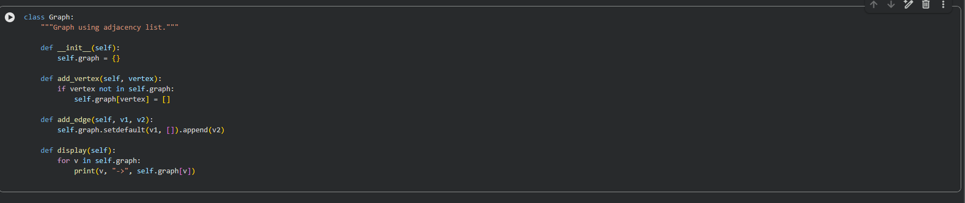
Task #7 – Priority Queue
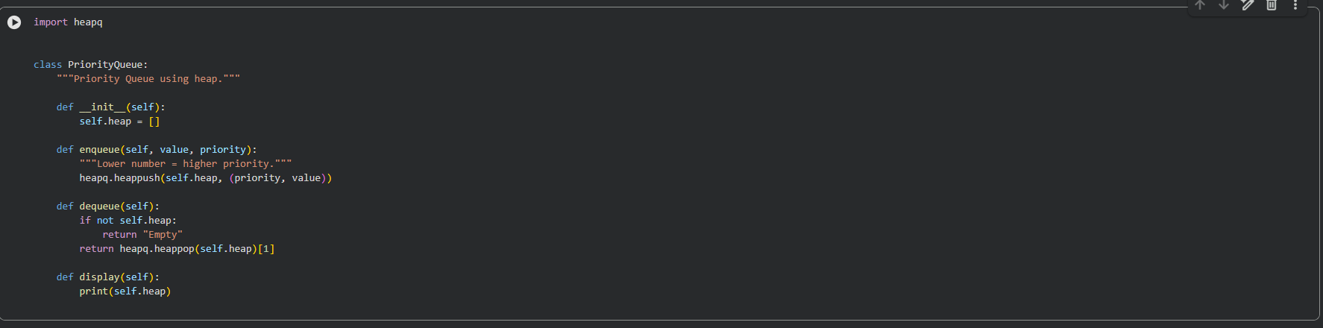

Task #8 – Deque
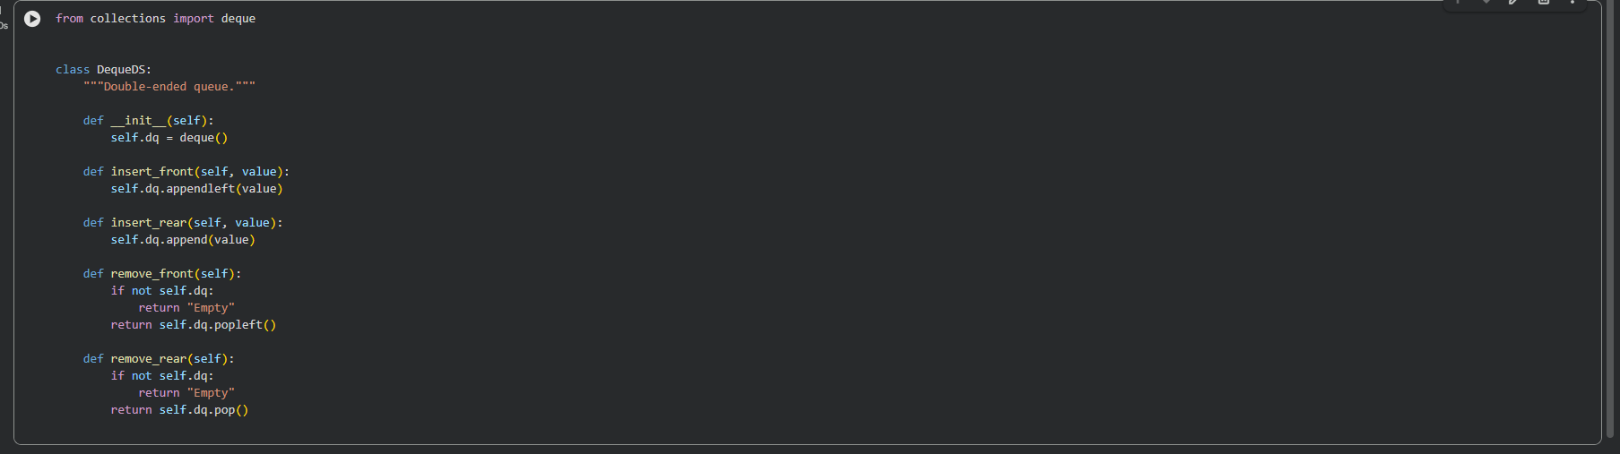
Task #9 – Campus Resource Management System

Feature Mapping Table
Feature | Data Structure | Justification
Student Attendance | Deque | Students enter and exit from both ends, making deque efficient for real-time logging.
Event Registration | Hash Table | Fast search, insertion, and deletion based on student ID.
Library Borrowing | Linked List | Dynamic insertion and removal of books without shifting elements.
Bus Scheduling | Graph | Routes and stops form a network structure.
Cafeteria Orders | Queue | Orders processed in arrival order (FIFO).

Implementation – Cafeteria Order Queue
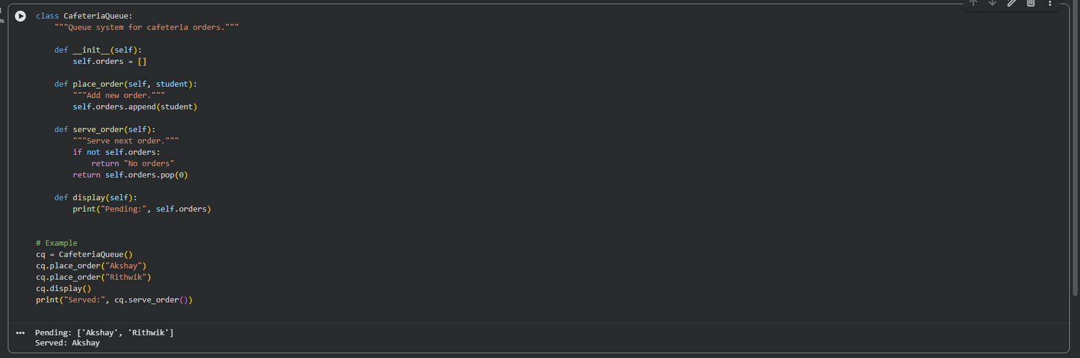

Task #10 – Smart E-Commerce Platform
Feature Mapping Table
Feature | Data Structure | Justification
Shopping Cart | Linked List | Dynamic addition and removal without shifting.
Order Processing | Queue | Orders handled sequentially.
Top-Selling Products | Priority Queue | Highest sales given priority.
Product Search | Hash Table | Fast lookup by product ID.
Delivery Planning | Graph | Represents routes between locations.

Implementation – Product Search using Hash Table
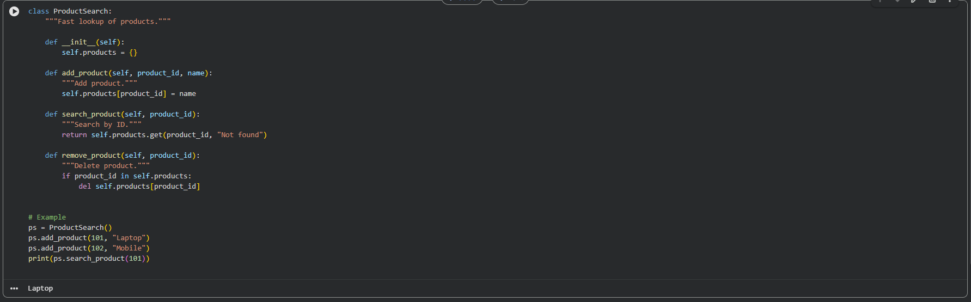

Conclusion
This lab demonstrated how AI can assist in:
- Designing and implementing core data structures
- Improving documentation and readability
- Selecting optimal structures for real-world applications
- Enhancing efficiency and scalability

